**Creat a social media post using canva**

# Introduction

* 1. overview

A social media post is an briefly conveying an event or a program to the public. For social media post use canva app it easy.

* 1. Purpose

With social media you can share information and ideas in a variety of ways .Different outlets allow you to publish your own ideas in writing with pictures or through videos and voice recordings and you can also hyperlink you audience to interesting articles pictures and videos.

# Problem definition and design thinking

* 1. Empathy map

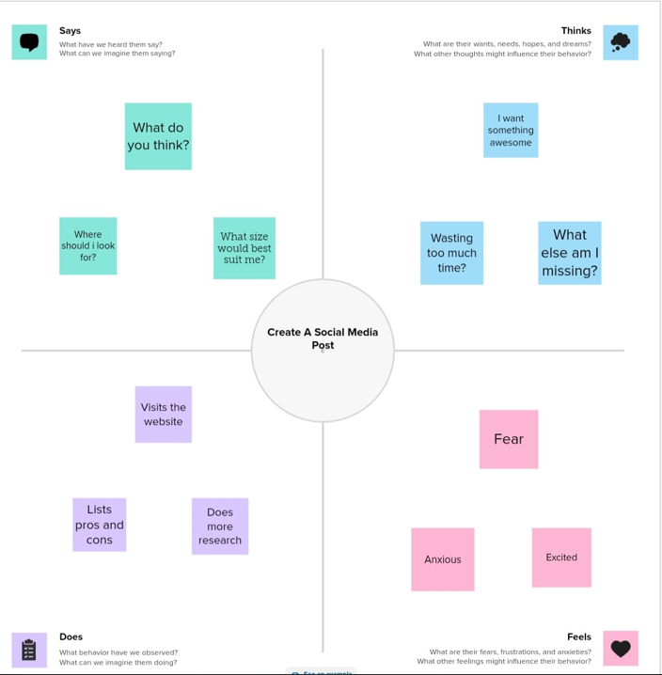

* 1. Ideation & Brainstorming map

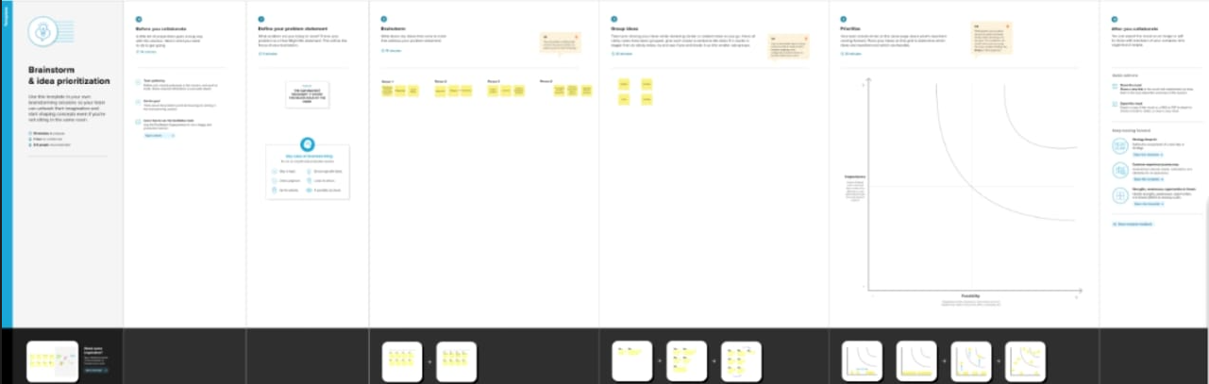

# Result



# Advantages & disadvantages

* 1. Advantages
* Social media post allows you to reach a large audience and build your brand.
* You can share relevant information or content with this audience.
* Which is helpful if you want people to follow you on social media .

4.2 Disadvantages

* Social media is addictive and can consume your time if you don’t have any other interests.
* It would help if you kept up with your studies and hobbies to stay productive.
* Social media makes us more self centered and less empathetic towards others.

# 5.Applications

Instagram , facebook , twitter , whatsapp posting on such websites can be taken as a poster and notice whenever necessary.

# 6.Conclusion

There is no escaping social media these days either for individuals or for businesses. Today it is impossible to separate social media from the online world.

# 7.Future scope

With this social media post creating in the future if there is a function organizer or an event manager I will create the necessary social media poster myself.